EBUS PRE-TEST

Q1. For a patient with a peripheral clinical stage IA tumor and negative nodal involvement on both CT and PET scans, what is the recommended approach to invasive mediastinal staging?
A. Invasive staging should always be performed using EBUS.
B. It is suggested that invasive pre-operative evaluation of the mediastinal nodes is not required.
C. Mediastinoscopy must be performed before any surgical resection.
D. Invasive staging is only required if the patient has a history of smoking.
Correct answer: B

Q2. The patient with the nodule below has a radiographically normal mediastinum (by CT and PET) what is the recommended best practice?
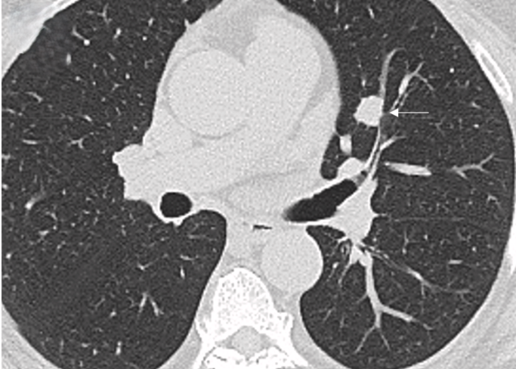
A. Staging by imaging alone.
B. Proceeding directly to surgery with intra-operative node dissection.
C. Invasive staging of the mediastinum.
D. Radiation therapy before any staging.
Correct answer: C

Q3. Which lymph node station corresponds to the subcarinal nodes?
A. Station 2R
B. Station 4L
C. Station 7
D. Station 10R
Correct answer: C

Q4. Which of the following lymph node stations is classified as an N1 node?
A. Station 4
B. Station 7
C. Station 9
D. Station 10
Correct answer: D

Q5. Station 5 lymph nodes are anatomically described as:
A. Subcarinal nodes
B. Subaortic (A-P window) nodes
C. Para-aortic nodes
D. Paraesophageal nodes
Correct answer: B

Q6. Which station represents the pre-vascular and retrotracheal nodes?
A. Station 2
B. Station 3
C. Station 6
D. Station 8
Correct answer: B

Q7. What is the anatomical definition of Station 8 nodes?
A. Paraesophageal (below carina)
B. Pulmonary Ligament
C. Para-aortic
D. Upper Paratracheal
Correct answer: A

Q8. Which lymph node station is represented in this image?
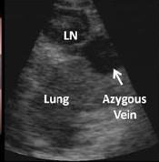
A. 4R
B. 4L
C. 10R
D. 10L
Correct answer: C

Q9. Based on the IASLC borders, which nodal station is situated along the ascending aorta or phrenic nerve?
A. Station 3a
B. Station 5
C. Station 6
D. Station 9
Correct answer: C

Q10. When preparing a slide for ROSE, which of the following is a recommended practice?
A. Touch the needle tip directly to the slide to ensure sample transfer.
B. Apply vigorous compression between the two slides to spread the sample.
C. Use a shield slide to prevent spraying and wasting the material.
D. Discard any blood clots obtained during aspiration.
Correct answer: C

Q11. Which of the following is considered a classic cytohistologic feature of the granuloma 'core' in sarcoidosis?
A. Abundant caseating necrosis
B. Epithelioid histiocytes and scattered lymphocytes
C. Reed-Sternberg cells
D. Predominantly malignant squamous cells
Correct answer: B

Q12. When evaluating the diagnostic yield for sarcoidosis, how does EBUS-TBNA compare to conventional ("blind") TBNA (CTBNA)?
A. Conventional TBNA has a significantly higher diagnostic yield.
B. Both modalities have equal diagnostic yields.
C. EBUS-TBNA provides a significantly superior diagnostic yield.
D. EBUS-TBNA is superior only when evaluating extrathoracic nodes.
Correct answer: C

Q13. Which medium should be used to collect cells specifically intended for flow cytometry when lymphoma is suspected?
A. Formalin
B. Saline
C. Ethanol
D. RPMI
Correct answer: D

Q14. Which of the following endemic mycoses is associated with a low frequency of thoracic lymphadenopathy, distinguishing it from the others listed?
A. Coccidioides
B. Histoplasma
C. Blastomyces
D. Cryptococcus
Correct answer: D

Q15. What does the prefix "y" indicate in the context of staging assessments?
A. Stage as determined by autopsy
B. After resection, made on the basis of pathologic assessment
C. After part or all of the treatment has been given
D. Stage at the time of a recurrence
Correct answer: C

Q16. According to the IASLC 9th Edition TNM Staging, a tumor that is 6 cm in size and does not invade other structures is classified as:
A. T2a
B. T2b
C. T3
D. T4
Correct answer: C

Q17. A primary tumor of any size that invades the mediastinum, heart, or great vessels is classified as:
A. T2
B. T3
C. T4
D. M1a
Correct answer: C

Q18. How is lymph node involvement (N) classified if there is metastasis in contralateral mediastinal or supraclavicular nodes?
A. N0
B. N1
C. N2
D. N3
Correct answer: D

Q19. How is the T classification determined for a patient with multifocal ground glass or part-solid nodules?
A. Distinct separate cTNM and pTNM stages are assigned for each cancer.
B. The T stage is based on the highest T lesion, with an indicator for multiplicity.
C. It is automatically classified as T4 due to multiple nodules.
D. The T stage is based on the total combined size of all nodules.
Correct answer: B

Q20. Which of the following lymph node stations is accessible via Endobronchial Ultrasound (EBUS)?
A. Station 5 (Subaortic)
B. Station 8 (Paraesophageal)
C. Station 7 (Subcarinal)
D. Station 9 (Pulmonary ligament)
Correct answer: C

Q21. When standard EBUS and EUS-B are combined for nodal staging, which lymph node station is still not routinely accessible?
A. Station 3p
B. Station 5
C. Station 6
D. Station 7
Correct answer: C

Q22. Which lymph node station is represented in this image?
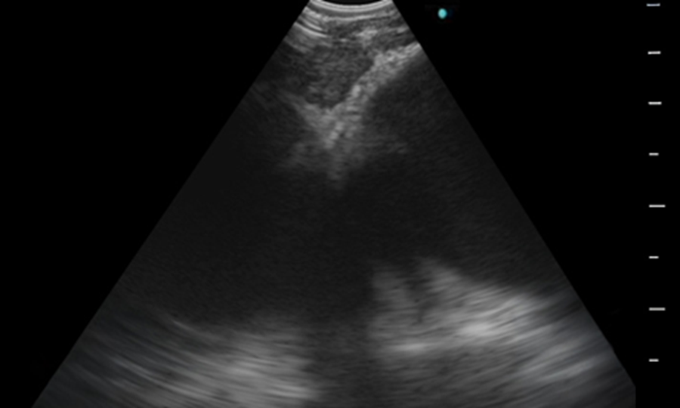
A. 4R
B. 4L
C. 10R
D. 10L
Correct answer: B

Q23. When evaluating a cytology sample from an EBUS TBNA, which of the following accurately describes the differences between Wright-Giemsa (WG) and Papanicolaou (Pap) stains?
A. WG is alcohol-based and better for evaluating nuclear features, while Pap is water-based.
B. WG is water-based and better for evaluating cytoplasmic features, while Pap is alcohol-based and better for evaluating nuclear features.
C. WG requires 15 steps and takes 3 minutes to perform.
D. Both stains are equally fast, taking roughly 45 seconds to perform.
Correct answer: B

Q24. According to current lung tumor pathology classification, which terms should be minimized or avoided when possible in small diagnostic specimens?
A. Adenocarcinoma in situ (AIS)
B. Minimally invasive adenocarcinoma (MIA)
C. Non-small cell lung cancer - not otherwise specified (NSCLC - NOS) and bronchoalveolar carcinoma (BAC)
D. Squamous cell carcinoma
Correct answer: C

Q25. According to current best practice for small lung biopsies or cytology, what constitutes a sufficient limited initial immunohistochemistry (IHC) panel to distinguish adenocarcinoma from squamous cell carcinoma?
A. A large panel of 5-10 markers to ensure accuracy.
B. One squamous cell carcinoma marker (e.g., p63, p40) and one adenocarcinoma marker (e.g., TTF-1, napsin A).
C. Only neuroendocrine markers like synaptophysin and chromogranin.
D. Testing for EGFR and KRAS mutations directly without IHC.
Correct answer: B

Q26. A patient's lung tumor biopsy shows an immunohistochemical (IHC) profile of TTF-1 positive (90%+) and positive for neuroendocrine markers such as Synaptophysin. Based on common IHC markers for lung cancers, this profile is most characteristic of:
A. Non-mucinous adenocarcinoma
B. Squamous cell carcinoma
C. Small cell carcinoma
D. Mesothelioma
Correct answer: C

Q27. When preparing an EBUS TBNA specimen for molecular marker testing, which fixative should be strictly avoided due to its incompatibility with molecular assays?
A. 10% neutral-buffered formalin
B. 70% ethanol (Alcohol)
C. Heavy metal fixatives (e.g., Zenker, acid zinc formalin)
D. Saline
Correct answer: C

Q28. Does applying suction during an EBUS-TBNA pass improve the diagnostic results compared to not using suction?
A. Yes, suction significantly improves sample quality.
B. No, using suction versus no suction results in no significant difference.
C. Yes, suction is required to diagnose adenocarcinoma.
D. No, suction actually ruins the cellular architecture.
Correct answer: B

Q29. What is the current overall diagnostic performance of EBUS-TBNA for lymphoma?
A. It is the gold standard with near-100% sensitivity.
B. It is more sensitive for de novo lymphoma than for recurrent disease.
C. It has a moderate pooled sensitivity of about 66% overall and tends to perform better for suspected recurrence than for de novo disease.
D. It is useful only when paired with ROSE.
Correct answer: C

Q30. What happens to the diagnostic yield when Endoscopic Ultrasound (EUS) is combined with EBUS?
A. The diagnostic yield slightly decreases due to procedural complications.
B. The diagnostic yield is exactly the same as using EBUS alone.
C. The diagnostic yield is slightly higher.
D. The combination is only used for gastrointestinal tumors.
Correct answer: C

Q31. You perform a linear EBUS-TBNA on a patient. During the procedure, you sample lymph nodes at stations 4L, 7, 4R, and 11R. Which CPT code should be used as the primary code for this procedure?
A. 31652
B. 31653
C. 31654
D. 31629
Correct answer: B

Q32. A physician provides moderate sedation during a bronchoscopy, with a total continuous face-to-face sedation time of 49 minutes. How should this sedation be billed?
A. 99152 x 1, 99153 x 2
B. 99152 x 1, 99153 x 3
C. 99152 x 3
D. 99152 x 1, 99153 x 1
Correct answer: A

Q33. What is a primary consequence of a false positive result when relying on imaging alone for mediastinal staging?
A. It guarantees extensive mediastinal infiltration.
B. It confirms distant metastases.
C. It subjects the patient to unnecessary surgical risk.
D. It may deny the patient the benefit of curative surgical resection.
Correct answer: D

Q34. Which lymph node station is accessible by Endoscopic Ultrasound (EUS) but NOT typically by Endobronchial Ultrasound (EBUS)? (Refer to the anatomical diagram on Page 7)
A. Station 4
B. Station 7
C. Station 8
D. Station 10R
Correct answer: C

Q35. For patients presenting with a high clinical suspicion of N2 or N3 involvement, what is recommended as the "best first test" for invasive staging?
A. PET scan evaluation only
B. Cervical Mediastinoscopy
C. A needle technique (EBUS, EUS, or combined EBUS/EUS)
D. Chamberlain procedure
Correct answer: C

Q36. What is a key clinical benefit of surveying and biopsying radiographically "negative" lymph nodes using EBUS?
A. It helps to identify and upstage patients to N2/N3 disease that CT and PET scans missed.
B. It confirms that radiographically negative nodes never harbor malignancies.
C. It prevents the need for any pre-operative imaging.
D. It exclusively isolates squamous cell carcinomas.
Correct answer: A

Q37. According to current CHEST guidance for suspected malignant disease, how many EBUS-TBNA needle passes are recommended per target lesion?
A. 1 pass
B. 2 passes
C. 3 or fewer passes
D. 4 or more passes
Correct answer: D

Q38. What is the primary proven benefit of utilizing Rapid On-Site Evaluation (ROSE) during an EBUS procedure?
A. It significantly increases the overall diagnostic yield.
B. It decreases overall procedural time.
C. It decreases the need for further biopsies/additional procedures.
D. It eliminates the need for any standard pathological evaluation.
Correct answer: C

Q39. How does the diagnostic performance of EBUS-TBNA compare to standard surgical mediastinoscopy?
A. Mediastinoscopy has a significantly higher sensitivity than EBUS-TBNA.
B. EBUS-TBNA has similar or slightly better sensitivity and accuracy compared to mediastinoscopy.
C. Mediastinoscopy has a 100% negative predictive value, making EBUS obsolete.
D. EBUS-TBNA can only sample the subcarinal nodes, unlike mediastinoscopy.
Correct answer: B

Q40. According to the AQUIRE Data Registry, how does the use of a 21-gauge needle compare to a 22-gauge needle during EBUS?
A. 21G has a significantly higher diagnostic yield for malignancy.
B. 22G is much less effective for cytology specimens.
C. There is no difference in sample adequacy or diagnostic yield.
D. 21G guarantees a specific diagnosis in 88% of cases.
Correct answer: C

Q41. Which of the following sets of ultrasound characteristics are considered "high risk" features for a malignant lymph node?
A. Oval, distinct border, homogeneous, presence of central hilar structure.
B. Round, indistinct border, heterogeneous, absence of central hilar structure.
C. Round, heterogeneous, distinct border, coagulation necrosis sign.
D. Oval, distinct border, homogeneous, absence of coagulation necrosis.
Correct answer: C

Q42. In EBUS elastography, how is a Type 3 (hard) lymph node typically characterized, and what does it suggest?
A. It deforms easily under compression and is 96.3% benign.
B. It deforms less than softer tissues and is 87.1% malignant.
C. It shows a predominantly green/red color and indicates a central hilar structure.
D. It deforms less than softer tissues and is 75.0% benign.
Correct answer: B

